Ideation Phase

Define the Problem Statements

|  |  |
| --- | --- |
| Date | 18 October 2022 |
| Team ID | PNT2022TMID24120 |
| Project Name | Project – Plasma Donor Application |
| Maximum Marks | 2 Marks |

**Donor & Donee Problem Statement Template:**

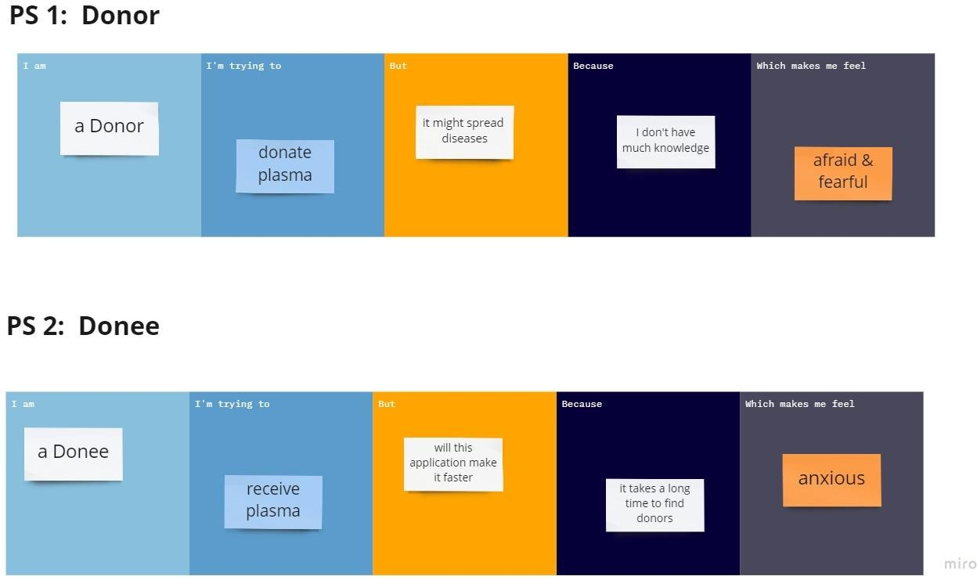

|  |  |  |  |  |  |
| --- | --- | --- | --- | --- | --- |
| **Problem**  **Statement (PS)** | **I am**  **(User)** | **I’m trying to** | **But** | **Because** | **Which makes me**  **feel** |
| PS-1 | A Donor | Donate plasma | it might spread diseases | I don’t  have  knowledge | Afraid and fearful |
| PS-2 | A Donee | Receive plasma | With this application make it faster | It takes a long time to find  donors | Anxious |